

**NAME: AMY TANYA WANJALA**

**ADM NO: BSE-05-0178/2022**

**ASSIGNMENT TWO**

**PHP FEEDBACK FORM DOCUMENTATION**

CAMPAIGN FEEDBACK

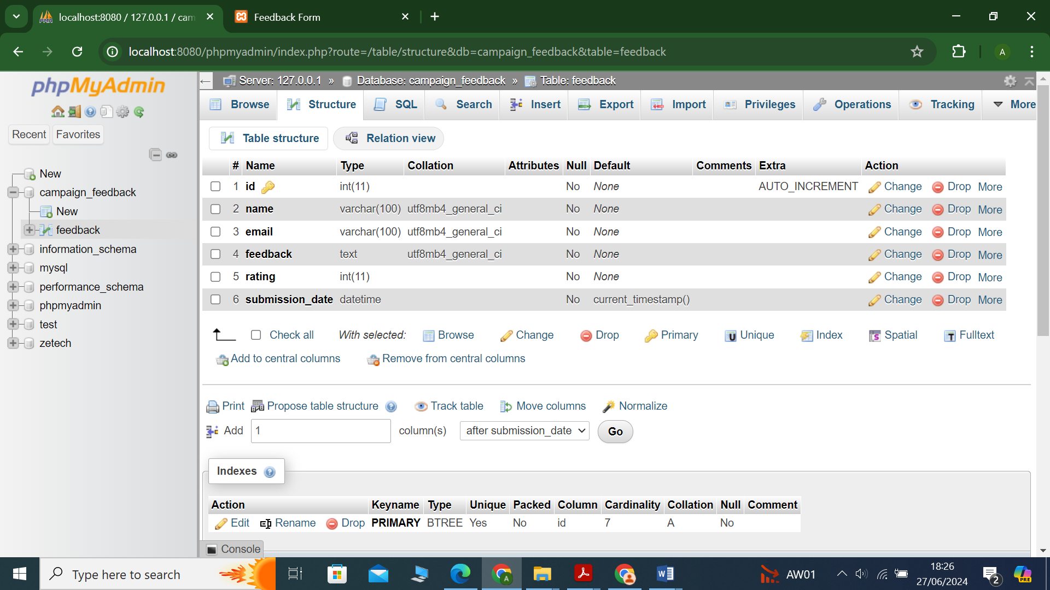

Figure :Feedback table

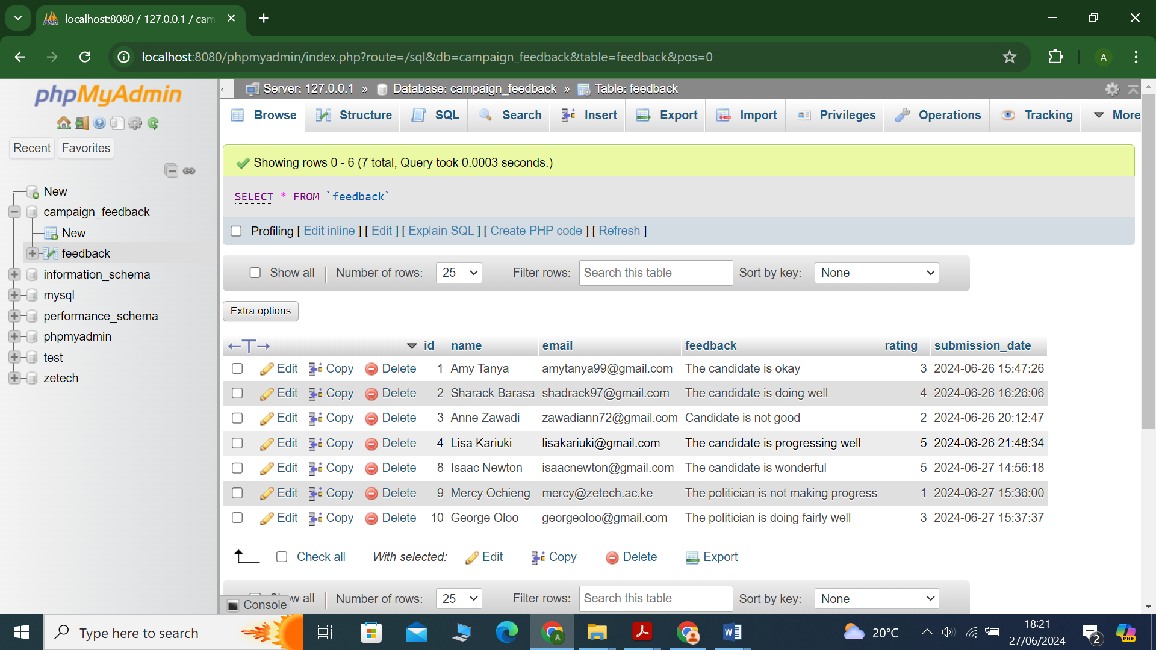

Figure : Feedback table data

FEEDBACK FORM

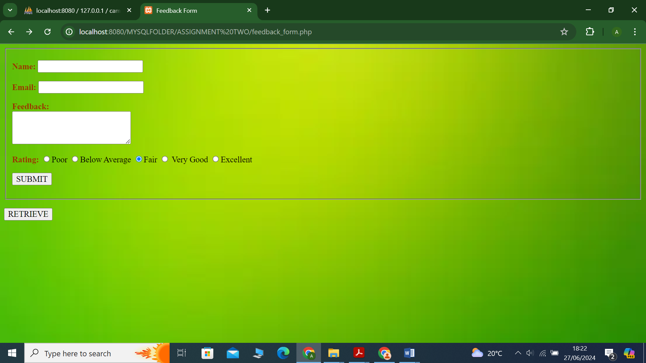

Figure : Form Layout

ERROR HANDLING

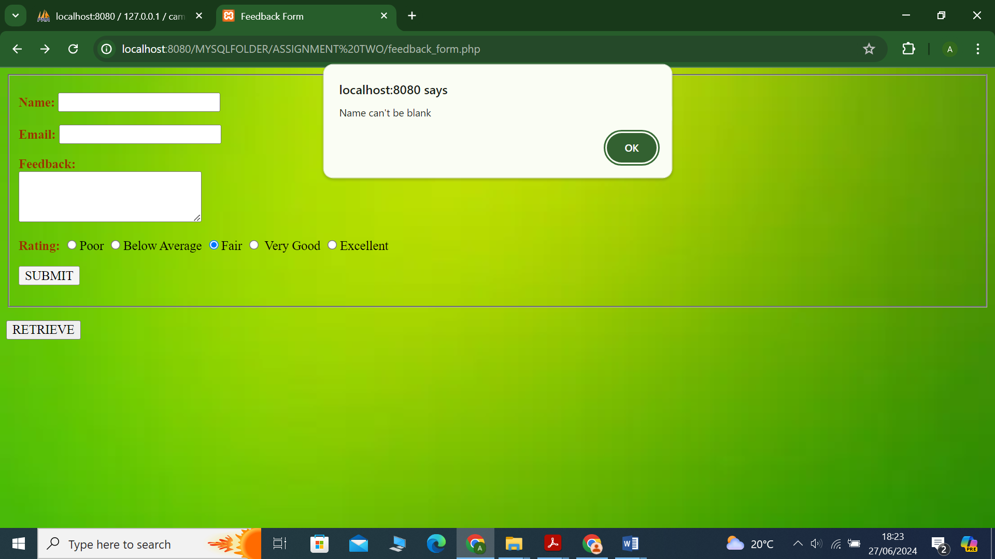

Error

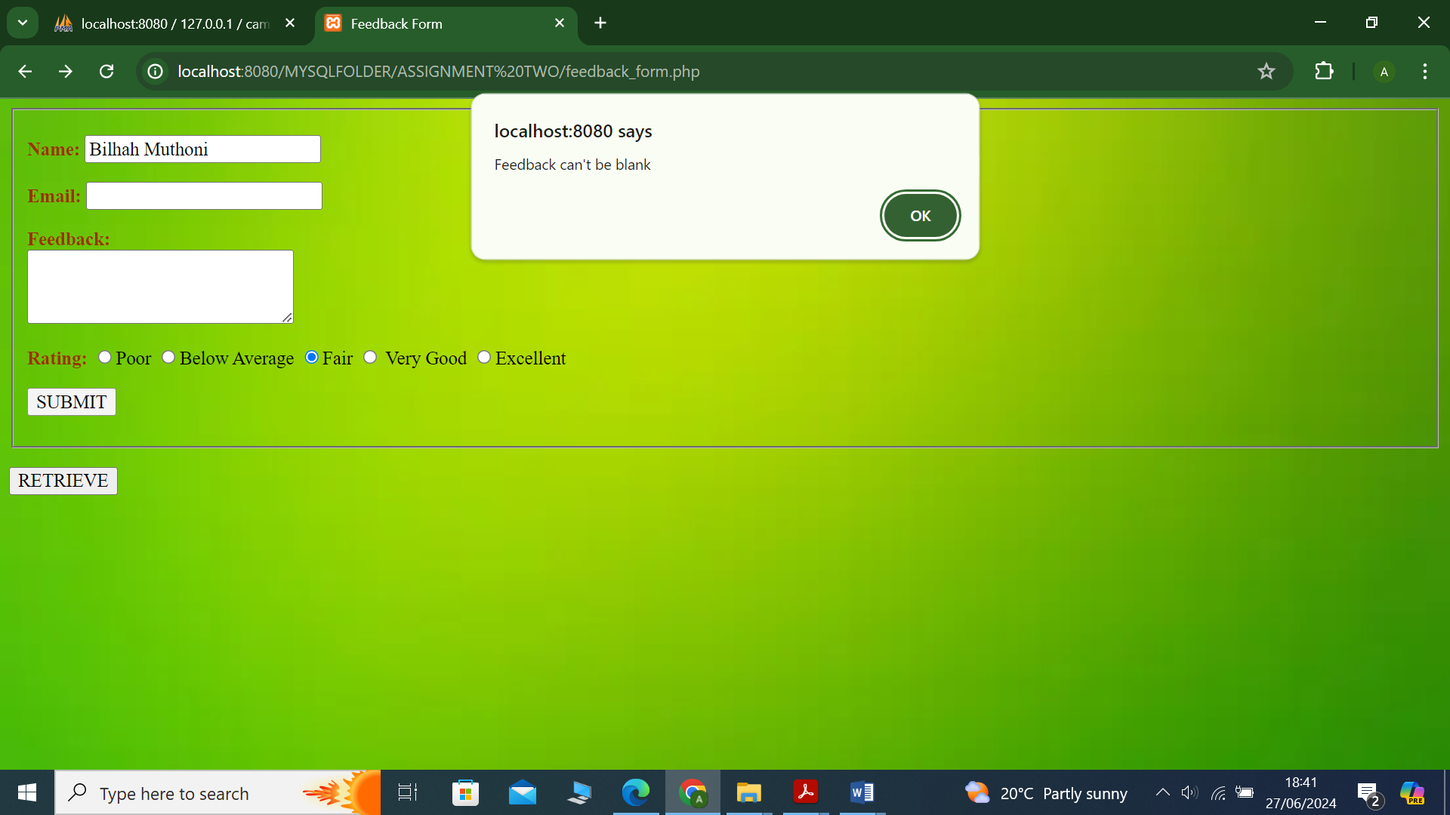

Error

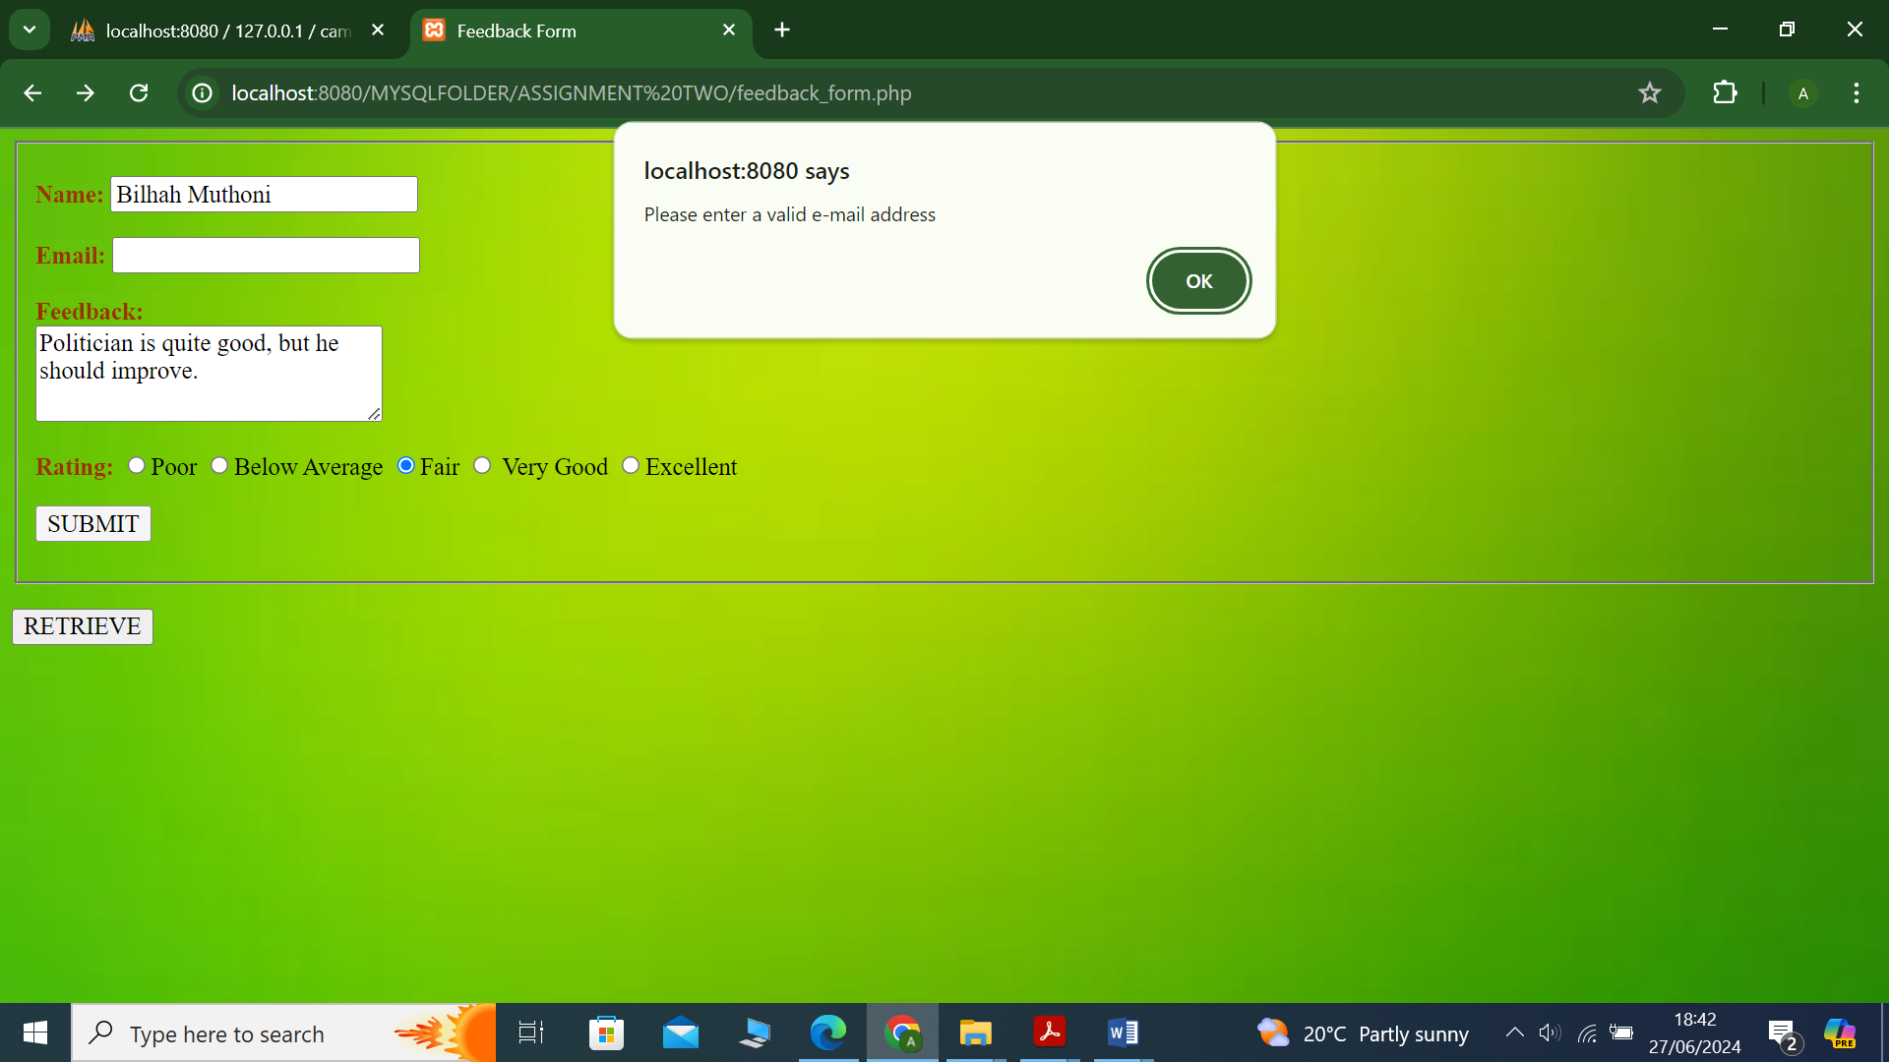

Error

DATA RETRIEVAL

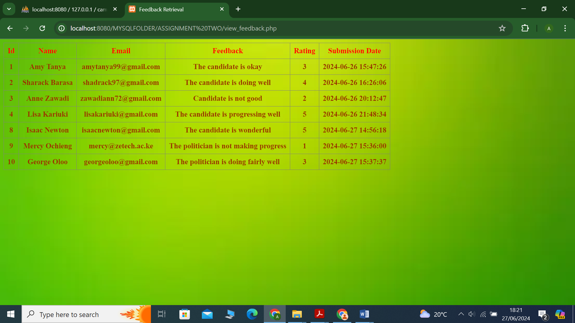

Figure : Data retrieval